News & Views From
St Mary’s Church Ecclesfield

Church Magazine June 2022

stmarysecclesfield.org.uk Price 60p

First Words

June begins with the celebration of the Queen’s Platinum Jubilee.
On Thursday 2nd June we will gather in the Churchyard at 9.30pm ready for the Beacon Lighting at 9.45pm.
On Sunday 5th June at 10 am we have a special Jubilee Celebration service followed by a picnic in the Churchyard.
Sunday 5th June is also Pentecost and there will be a celebration of the Eucharist at 6.30pm.
In between these festivities there will be a wedding in Church on Saturday 4th June at 4pm.
On Monday 6th June we welcome Chapeltown Scouts to Church at 8pm.
On Wednesday 8th June at 2pm there will be a service of Renewal of Wedding vows.
On Saturday 11th June it is the monthly Prayer Breakfast at 9am and a wedding in Church at 3pm.
On Sunday 12th June Tim will be presiding at a Baptism at St Mark’s Grenoside at 12 noon.
Tim will be away on training to have a curate from Monday 13th to Tuesday 14th June.
Wednesday 15th June at 3pm Soul Sanctuary - Meditation & Contemplative Prayer for beginners.
Sunday 19th June is Father’s Day. There will be an All-Age Celebration service at 10am and Baptisms at 12 noon.
On Tuesday 21st June we will meet in Church to plan worship and choose hymns for July.
On Friday 24th June at 2pm there is a wedding in Church.
And on Sunday 26th June, Sam Ellmore, our curate will be ordained in Sheffield Cathedral.
Monday 27th June 7pm Baptism Preparation.
Tuesday 28th June 6.30pm Brownies visit to Church.
Thursday 30th June 10.30am St Mary’s Gathering, - a time for prayer, fellowship, Bible study & discussion.
Another busy month with lots to look forward to, especially teh arrival of Sam, Maria, Ramona and Aela. Please keep them in your prayers as they prepare to join us.

God bless,

Tim

--------------

Front Cover – Official NPO image – © Jacob King/PA Wire/PA Images.
#PlatinumJubilee and #HM70
Back Cover – Through the Lych gate
Andrew Jones
Tui Na Massage & Acupuncture

Treating all types of pain, stress and discomfort

Kinetic Clinic
The Old Griffin Pub
8 Townend Road
Ecclesfield

Mob: 0753 806 5665
andrewjoneshealth@gmail.com
www.acupunctureandmassage.net
Piano Lessons

Take Exams or play for fun.

Theory up to Grade 5 beginners welcome.

Alison Hancock – 0114 245 2780

Yorke Salon
Ladies and Gents Hair Salon
Monday  Tuesday  Wednesday | 8:30am to 11am  Closed  9am to 12am | Thursday  Friday  Saturday | 9am to 12am -- 1pm to 5pm Nicole 9am to 12am -- 1pm to 6pm Nicole  8:30am to 12am
315 High Street Ecclesfield S35 9NB
Salon Telephone: 0114 246 7762
The Queen’s Green Canopy

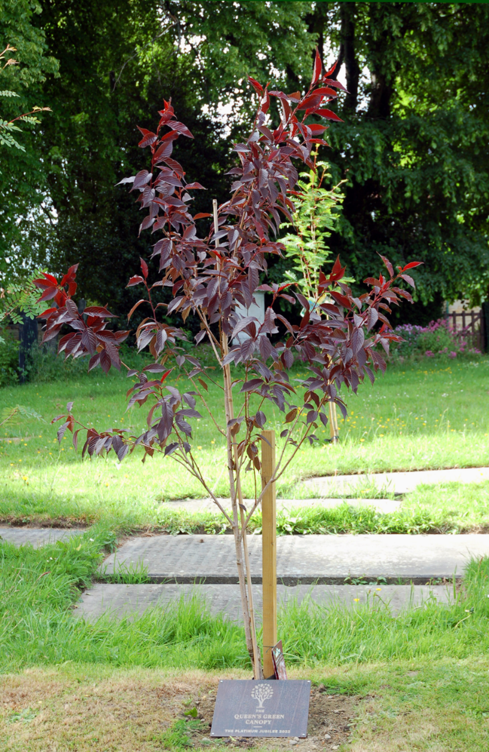
As you walk along the Lych Gate path you may have noticed to the left three newly planted trees, these are part of The Queen’s Green Canopy (QGC).

QGC is a unique tree planting initiative created to mark Her Majesty’s Platinum Jubilee in 2022 which invites people from across the United Kingdom to “Plant a Tree for the Jubilee”.

Everyone from individuals to Scout and Girlguiding groups, villages, cities, counties, schools and corporates is being encouraged to play their part to enhance our environment by planting trees during the official planting season between October to March. Tree planting will commence again in October 2022, through to the end of the Jubilee year.

As well as inviting the planting of new trees, The Queen’s Green Canopy will dedicate a network of 70 Ancient Woodlands across the United Kingdom and identify 70 Ancient Trees to celebrate Her Majesty’s 70 years of service.

If you wish to plant a tree in your garden to commemorate the Platinum Jubilee visit: https://queensgreencanopy.org/

Ecclesfield Priory Players

EPPiC Theatre - Coffee Morning

Saturday 25th June 2022
Coffee and Chords 10.45 am

Free entertainment provided by folk singer
John Snook and friends

EPPiC Theatre, Well Lane, Ecclesfield, Sheffield, S35 9TP

The Queen’s Platinum Jubilee
Canon Paul Hardingham

This month we celebrate the Queen’s Platinum Jubilee. She is the longest reigning monarch in British history. Up until recently she attended church every week and still did a full week’s work at the age of 96!

It is her commitment to serving God and the nation which stands out in her life. Even before she became Queen, she made a promise, which she has kept for over 75 years: ‘I declare before you all that my whole life, whether it be long or short, shall be devoted to your service’ (21st birthday broadcast, 21 April 1947).

What is the secret of the Queen’s consistency of character and service? In 2002 she said this: “I know just how much I rely on my faith to guide me through the good times and the bad. Each day is a new beginning. I know that the only way to live my life is to try to do what is right, to take the long view, to give of my best in all that the day brings, and to put my trust in God.” These are wise words from somebody who draws her strength from the Christian Faith and can inspire all of us who want to make our lives count!

The Queen has been an example of joyful, wise, and generous service on behalf of others all her life. Six months before her coronation she asked the nation and Commonwealth to “pray that God may give me wisdom and strength to carry out the solemn promises I shall be making, and that I may faithfully serve Him and you, all the days of my life.” Paul urges us to pray for all in authority, “that we may live peaceful and quiet lives in all godliness and holiness.” (1 Timothy 2:2).

Saint of the Month - Columba of Iona - 9th June

In 563 AD St Columba sailed from Ireland to Iona – a tiny island off Mull, in the Western Highlands. He brought Christianity with him.

Columba (c. 521 -97) was born in Donegal of the royal Ui Neill clan, and he trained as a monk. He founded the monasteries of Derry (546), Durrow (c.556) and probably Kells. But in 565 Columba left Ireland with twelve companions for Iona, an island off southwest Scotland. Iona had been given to him for a monastery by the ruler of the Irish Dalriada.

Why would a monk in his mid-40s go into such voluntary exile? Various explanations include going into voluntary exile for Christ, an attempt to help overseas compatriots in their struggle for survival, or even as some sort of punishment for his part in a row over a psalter in Ireland. Whatever the reason, Columba went to Iona and spent the rest of his life in Scotland, returning to Ireland only for occasional visits.

Columba’s biographer, Adomnan, portrays him as a tall, striking figure of powerful build and impressive presence, who combined the skills of scholar, poet and ruler with a fearless commitment to God’s cause. Able, ardent, and sometimes harsh, Columba seems to have mellowed with age.

As well as building his monastery on Iona, Columba also converted Brude, king of the Picts. Columba had great skill as a scribe, and an example of this can be seen in the Cathach of Columba, a late 6th century psalter in the Irish Academy, which is the oldest surviving example of Irish majuscule writing. In his later years Columba spent much time transcribing books.

Columba’s death was apparently foreseen by his community, and even, it seems, sensed by his favourite horse. He died in the church just before Matins, and it is a tribute to this man that his traditions were upheld by his followers for about a century, not least in the Synod of Whitby and in Irish monasteries on the continent of Europe.

Here is a prayer of St Columba:

Christ With Us
My dearest Lord,
Be Thou a bright flame before me,
Be Thou a guiding star above me,
Be Thou a smooth path beneath me,
Be Thou a kindly shepherd behind me,
Today and evermore.

A beach on Iona - a thin place

In Irish Celtic lore, “thin places” are those locales where the veil between this world and the otherworld is porous, where there is mystery in the landscape. The earth takes on the hue of the sacred among peoples whose connection to place has remained unbroken through the ages.
God in The Arts
Editor: The Revd Michael Burgess continues his series on God in the Arts with a look at the famous Book of Kells…our picture shows an eagle from the famous book.

The Thread of God’s love
In 563 an Irish monk was forced to leave his homeland because of a conflict that had led to a misuse of power and even bloodshed. On Pentecost Sunday he arrived on the island of Iona off the north-west coast of Scotland with twelve companions. There he began a new way of life, founded on Christ’s mercy and forgiveness of the past, and so created one of the great centres of faith and mission in the Christian Church. His name was Columba, and we keep his feast day on 9th June.

His monastery on Iona started as a small cluster of wooden buildings with a church and a guesthouse. Around were fields of crops and cattle and bees. But under Columba’s guidance, it grew, and from Iona monks were sent into Scotland as one arm of a missionary advance that reached down through England to France and across Europe.

That outreach was an amazing achievement. But just as amazing was the consolidation of monastic life on Iona that resulted two centuries later in the Book of Kells. This text of the four Gospels was begun by scribes and artists in the library of Iona. It grew into one of the masterpieces of Celtic art that was taken to Kells in Ireland to escape the Viking invaders who ravaged the island.

Along with the text of the Gospels, there are illustrations of Jesus, Mary and the four evangelists, together with decorations at once intricate and fantastic: patterns that interweave and interlace across the page with an odd face here and a weird creature there. The design is in brilliant detail, and you can follow the lines as they weave in and out. This delight in patterns is evident in lots of Celtic art.

It is good to imagine Columba on Iona meditating on the thread of God’s grace woven into his life as he looked back to his years in Ireland and his pilgrimage to Iona. It might have seemed at one glance a complicated interweaving of events and experiences, and then perhaps as he looked again, he would see God’s love threading its way through that history and redeeming both it and him.
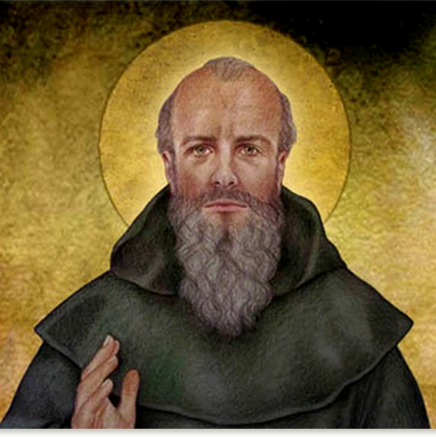
It is the same for us. As we look at our lives, they may seem complex and involved patterns of events and circumstances taking us here and there. As we ponder those patterns, then we can begin to see a thread woven into the patterns that guides and leads us on. And as we stand back, all the patterns and threads seem to make sense as we spot that guiding thread. Just as we can stand back from the designs of this page and see God’s love spelling out the name of Christ, our Lord.

St James the Least of All
Editor: The Revd Dr Gary Bowness continues his tongue-in-cheek letters from ‘Uncle Eustace’…

Beware all donations!
The Rectory
St. James the Least
My dear Nephew Darren.
This has been an unusual month: we have moved from hysterical excitement to deep disappointment within the space of days.

For many years, our vestry has displayed an oil painting generously donated by the Dowager Duchess of Stansby – given to us, I suspect, because her son, the tenth Duke, would not allow it in his house. It was supposed to depict Daniel in the lions’ den, although I always thought it looked more like a prospective adopter visiting a dog rescue centre. The Dowager was less than pleased when it wasn’t made the centrepiece in the sanctuary, but we managed to persuade her that her exceptional work of art would be safer from theft if locked away.

Then - our cleaner happened to knock it off the wall. If it had landed in her bucket of disinfectant and been totally destroyed, it would have been a sadness I suspect I could have learned to bear. But something more interesting happened. Some of the Dowager’s oil was chipped off – to reveal a painting underneath of what looked like a cherub.

The cleaner told the churchwarden, who instructed her not to tell anyone about the find. This inevitably meant that, within the hour, the entire parish knew of the discovery of what had already been transformed into a priceless pre-Raphaelite treasure. Our churchwarden has yet to learn the fact that if you tell someone something in complete confidence, they assume it means they can only tell one other person at a time.

By evening, mutually opposed camps had already formed. Miss Timmins wanted the treasure to be placed in a side chapel, as a shrine, preferably with candles permanently burning beside it. She envisaged St James the Least of All becoming a place of pilgrimage, and that this yet-to-be revealed cherub may work miracles of healing. She was already asking for opinions about where the car park should be built to cater for the thousands of tourists who would soon be flocking here. Another group wanted to sell it as soon as possible and use the money to repair our church tower. A third group insisted the fortune it would raise be given to African missionaries. Meanwhile, the tenth Duke was consulting his solicitors to see how he might get the canvas back to his castle.

We compromised by getting the thing X-rayed, to see what work of art lay underneath. It turned out to be by a local artist who had painted an advert for the village pharmacist to sell his own brand of gripe water.

Shrines, towers and good deeds were quietly forgotten and the last we heard of the tenth Duke was that he was consulting a second set of solicitors to see if he can get out of paying the first set for the work that they had done to retrieve the painting.

Your loving uncle,
Eustace
Coffee Shop
at St Mary’s Church

Every Tuesday and Friday 10.00 am to 12.00 pm

Luscious Cakes, Tea / Coffee

All Welcome – Free Internet Wi-Fi - Disabled friendly access

A. J. Hurdley - Opticians

NHS and Private Eye Examinations
Spectacles at Sensible Prices
125 High Street, Ecclesfield, Sheffield, S35 9UA
0114 246 8127

enquiries@ajhurdleyopticians.co.uk

Opening Hours for book borrowing & returns:
Mondays 1pm to 4pm
Wednesdays and Fridays 10am to 4pm
Saturdays 10am to 12pm

Come and check out the large range of new releases we have available to borrow courtesy of local Co-op Community Fund and Co-op Members.

Groups and Activities Now Running in the Library

Little Bears Club Fridays 10-11.30am
Knit & Natter Mondays 2-4pm and Wednesdays 12-3pm
Local History Group Last Wednesday of the month 2-4pm
Creative Writing Group First Wednesday of the month 6-8pm
Chairobics Thursdays 11.45 – 12.30pm

We also offer pre booked use of our PC’s, printing and photocopying services.
Tea & coffee can also be served for a small charge.

For more details about our events and activities
Call us on 0114 2463615 or follow us on Facebook or Twitter

Thought for the Month

This year marks the Queen’s Platinum Jubilee - seventy years serving the nation as head of state and also as the head of the Church. Elizabeth the Second is the longest serving monarch in history. It is a real privilege for us to be part of this national occasion.

The Jubilee is a time to celebrate and give thanks for an extraordinary life devoted to this country and its people as well as the peoples of the Commonwealth. Since ascending to the throne Queen Elizabeth has given an example of dedicated and selfless service, and something for which we give thanks.

This milestone gives us an opportunity to think, not only about Queen Elizabeth, but also about the institution of the monarchy and its role in Britain today.

One of the main reasons that I personally support the monarchy is that it gives us a Head of State who does not belong to any political party. This means that the monarch can represent the whole of the nation and every person in the nation. An elected president would be a political appointment and for that reason could not be a focus of national unity - just imagine President Blair or President Johnson!

In the past few years Britain has become increasingly divided, and we have been longing for the healing of our nation. I pray that in this Jubilee we will begin to see once again that we belong to one another. I pray that we will begin to see beyond the differences.

Jesus in the Gospels warns us that a divided kingdom cannot stand! It is a warning that we should take very seriously.

Whatever you do over the Jubilee long-weekend, take time to give thanks for our Queen and her seventy years of faithful service, and also take time to pray for this land, to commit its life and its future to the God that Elizabeth has served in her position as our Queen.

God bless you,
Tim

Miscellaneous observations on life and faith

The world is the first Bible that God made for the instruction of man. - Clemens Alexandrinus
Nature is the art of God. Thomas Browne
Love all, trust a few, and do wrong to none. - William Shakespeare
When I believe, I am no longer a mere man, I am already a son of God. - Carlo Carretto
Thou shalt ever joy at eventide if you spend the day fruitfully. - Thomas a Kempis
No one doth well what he doth against his will. - St Augustine of Hippo
I think that God’s works are so beautiful that I am amazed that people can admire them but deny that they have a Maker. - Commissioner Catherine Bramwell-Booth If we would understand divine things, we must cultivate an attitude of humble adoration. Who does not begin by kneeling down, runs every possible risk. - Ernest Hello
Mothers' Union

We met together at our monthly M.U. meeting in May to enjoy time together and listen to our speaker Sylvia Charles. Sylvia told us of some of the things she had been doing during lockdown.

One off her great idea’s was to search for any old photos and items which she has held onto over the years. They brought back lots of memories about her grandparents and her happy childhood. She made collages with some of the photos, letters, cards, and keepsakes.
She inspired us to look at our own unique family history and encouraged us to write journals for our children and grandchildren to read and pass onto future generations.

Most of us are at an age where we can remember things our grandchildren have never even heard of but can be so interesting to them. We need to preserve and pass on our memories of days gone by. So, get out all the things hidden away and don’t throw them out as they are very precious.

Besides all this, Sylvia has also written a very interesting book called Patchwork Philosophy which is well worth a read and beautifully presented.

We had a lovely afternoon and our next meeting is on Wednesday June 1st in the Gatty Hall. Our speaker Claire will tell us all about the Pause Project.
Everyone is welcome, Young and Old.

Planned Activities

Date | Time & Venue | Activity
1 June 2022 | 1.30pm Gatty Hall | Jeni Fryer - Inspiration
18 June 2022 | 2.00-5.00pm Bishopscroft | Bishops Garden Party  Theme Upcycling-Creation Care
6 July 2022 | 1.30pm Gatty Hall | Claire Parfrement - The Pause Project
3 August 2022: | 2.00-4.30pm Churchyard | Platinum Celebration Afternoon Tea  Proceeds to Summer of Hope Appeal
9 August 2022 | 2.00pm Cathedral | Mary Sumner Day Service
9 September 2022 | 6.00pm Gatty Hall | Caravan Drive
14 September 2022 | Winthrop Gardens TBA | Lunch/Tea - Holy Cross Day

With Pentecost in mind:

He who does not know God the Holy Spirit cannot know God at all. - Thomas Arnold

To the one who remembers the Spirit there is always a way out, even in the wilderness with the devil. - Herbert Brokering

The Holy Spirit … writes His own gospel and He writes it in the hearts of the faithful. - Jean-Pierre de Caussade SJ

From the Registers

Baptisms
Sunday 8th May Skylar Harper
Aurora Lennon
James Browne
Sunday 29th May Oliver Drew

May they know the love of God in their life and may all things of the Spirit live and grow in them

Marriages
Saturday 14th May Shaun Gladwin & Sharon Machin
Friday 20th May Gregg Patrick Cook & Jo-Anne Stanley
Saturday 21st May Luke McMillan & Abbi Renshaw

May each be to the other strength in need a comfort in sorrow and a companion in joy

Are we alone? - The search for extra-terrestrial life
The Fermi paradox

Italian physicist Enrico Fermi suggested in the 1950s that if technologically advanced civilizations are common in the universe, then they should be detectable in one way or another. Fermi asked; "Where is everybody?"
The Fermi paradox is commonly understood as asking why extra-terrestrial’s have not visited Earth, but the same reasoning applies to the question of why signals from extra-terrestrial’s have not been heard. The SETI version of the question is sometimes referred to as "the Great Silence".

The Fermi paradox can be stated more completely as follows:
The size and age of the universe incline us to believe that many technologically advanced civilizations must exist. However, this belief seems logically inconsistent with our lack of observational evidence to support it.

- Either the initial assumption is incorrect, and technologically advanced intelligent life is much rarer than we believe
- Or our current observations are incomplete, and we simply have not detected them yet
- Or our search methodologies are flawed and we are not searching for the correct indicators
- Or it is the nature of intelligent life to destroy itself

Enrico Fermi (1901 -1954) was an Italian (later naturalized American) physicist and the creator of the world's first nuclear reactor, the Chicago Pile-1. He has been called the "architect of the nuclear age" and the "architect of the atomic bomb". He was one of very few physicists to excel in both theoretical physics and experimental physics. Fermi was awarded the 1938 Nobel Prize in Physics for his work on induced radioactivity by neutron bombardment and for the discovery of transuranium elements. With his colleagues, Fermi filed several patents related to the use of nuclear power, all of which were taken over by the US government. He made significant contributions to the development of statistical mechanics, quantum theory, and nuclear and particle physics.
God in the Sciences
This series is written by Dr Ruth M Bancewicz, who is Church Engagement Director at The Faraday Institute for Science and Religion in Cambridge. Ruth writes on the positive relationship between Science and Christian faith.

Help, my kids just asked me a science question!

Why aren’t dinosaurs in the Bible?
The Bible wasn’t written to list all the animals on earth or tell us about science. It was written a long time before people started to use science to learn about the world.

When the Bible was written, people didn’t even have a word for dinosaurs yet! But it’s not just dinosaurs that aren’t mentioned in the Bible, it doesn’t talk about armadillos, kangaroos, sabre-toothed cats or penguins either!

That doesn’t mean that the Bible is out of date or wrong, or that these animals aren’t important. Rather than teaching us science, many Christians believe that the Bible was written to tell people about God, how much He loves them, and all the amazing things He has done.

The Bible says that God made everything, and loves everything He made, so that includes dinosaurs. It also encourages people to explore and find out all about the wonderful things it says God has made. Science is a part of this exploration.

Did God make the dinosaurs?

The Bible (the holy book that Christians read) says that God made everything. All the stars, the Earth and all the amazing plants and animals that have ever lived here. So yes, most Christians believe that God made the dinosaurs!

The Bible also teaches that God loves it when people explore His creation, and science is a great way of doing that. So, for many Christians, science is one of the fun things we can use to learn all about how God made everything, including all of the dinosaurs!

Were humans and dinosaurs ever living on earth at the same time?

Yes! But probably not the kind of dinosaur you’re thinking of! Most of the dinosaurs died out a very, very long time ago, way before humans first lived. But some of the smaller, feathery dinosaurs survived and over a long time they have evolved into the animals we call birds.

So, from chickens and robins to penguins and ostriches, there are dinosaurs living all over our world today!

These questions and answers are taken from The Faraday Kids website (www.faradaykids.com). For even more science-faith Q&A's, check out 101 Great Big Questions About God and Science, Edited by L Henderson & S Bryant (Lion, 2022)

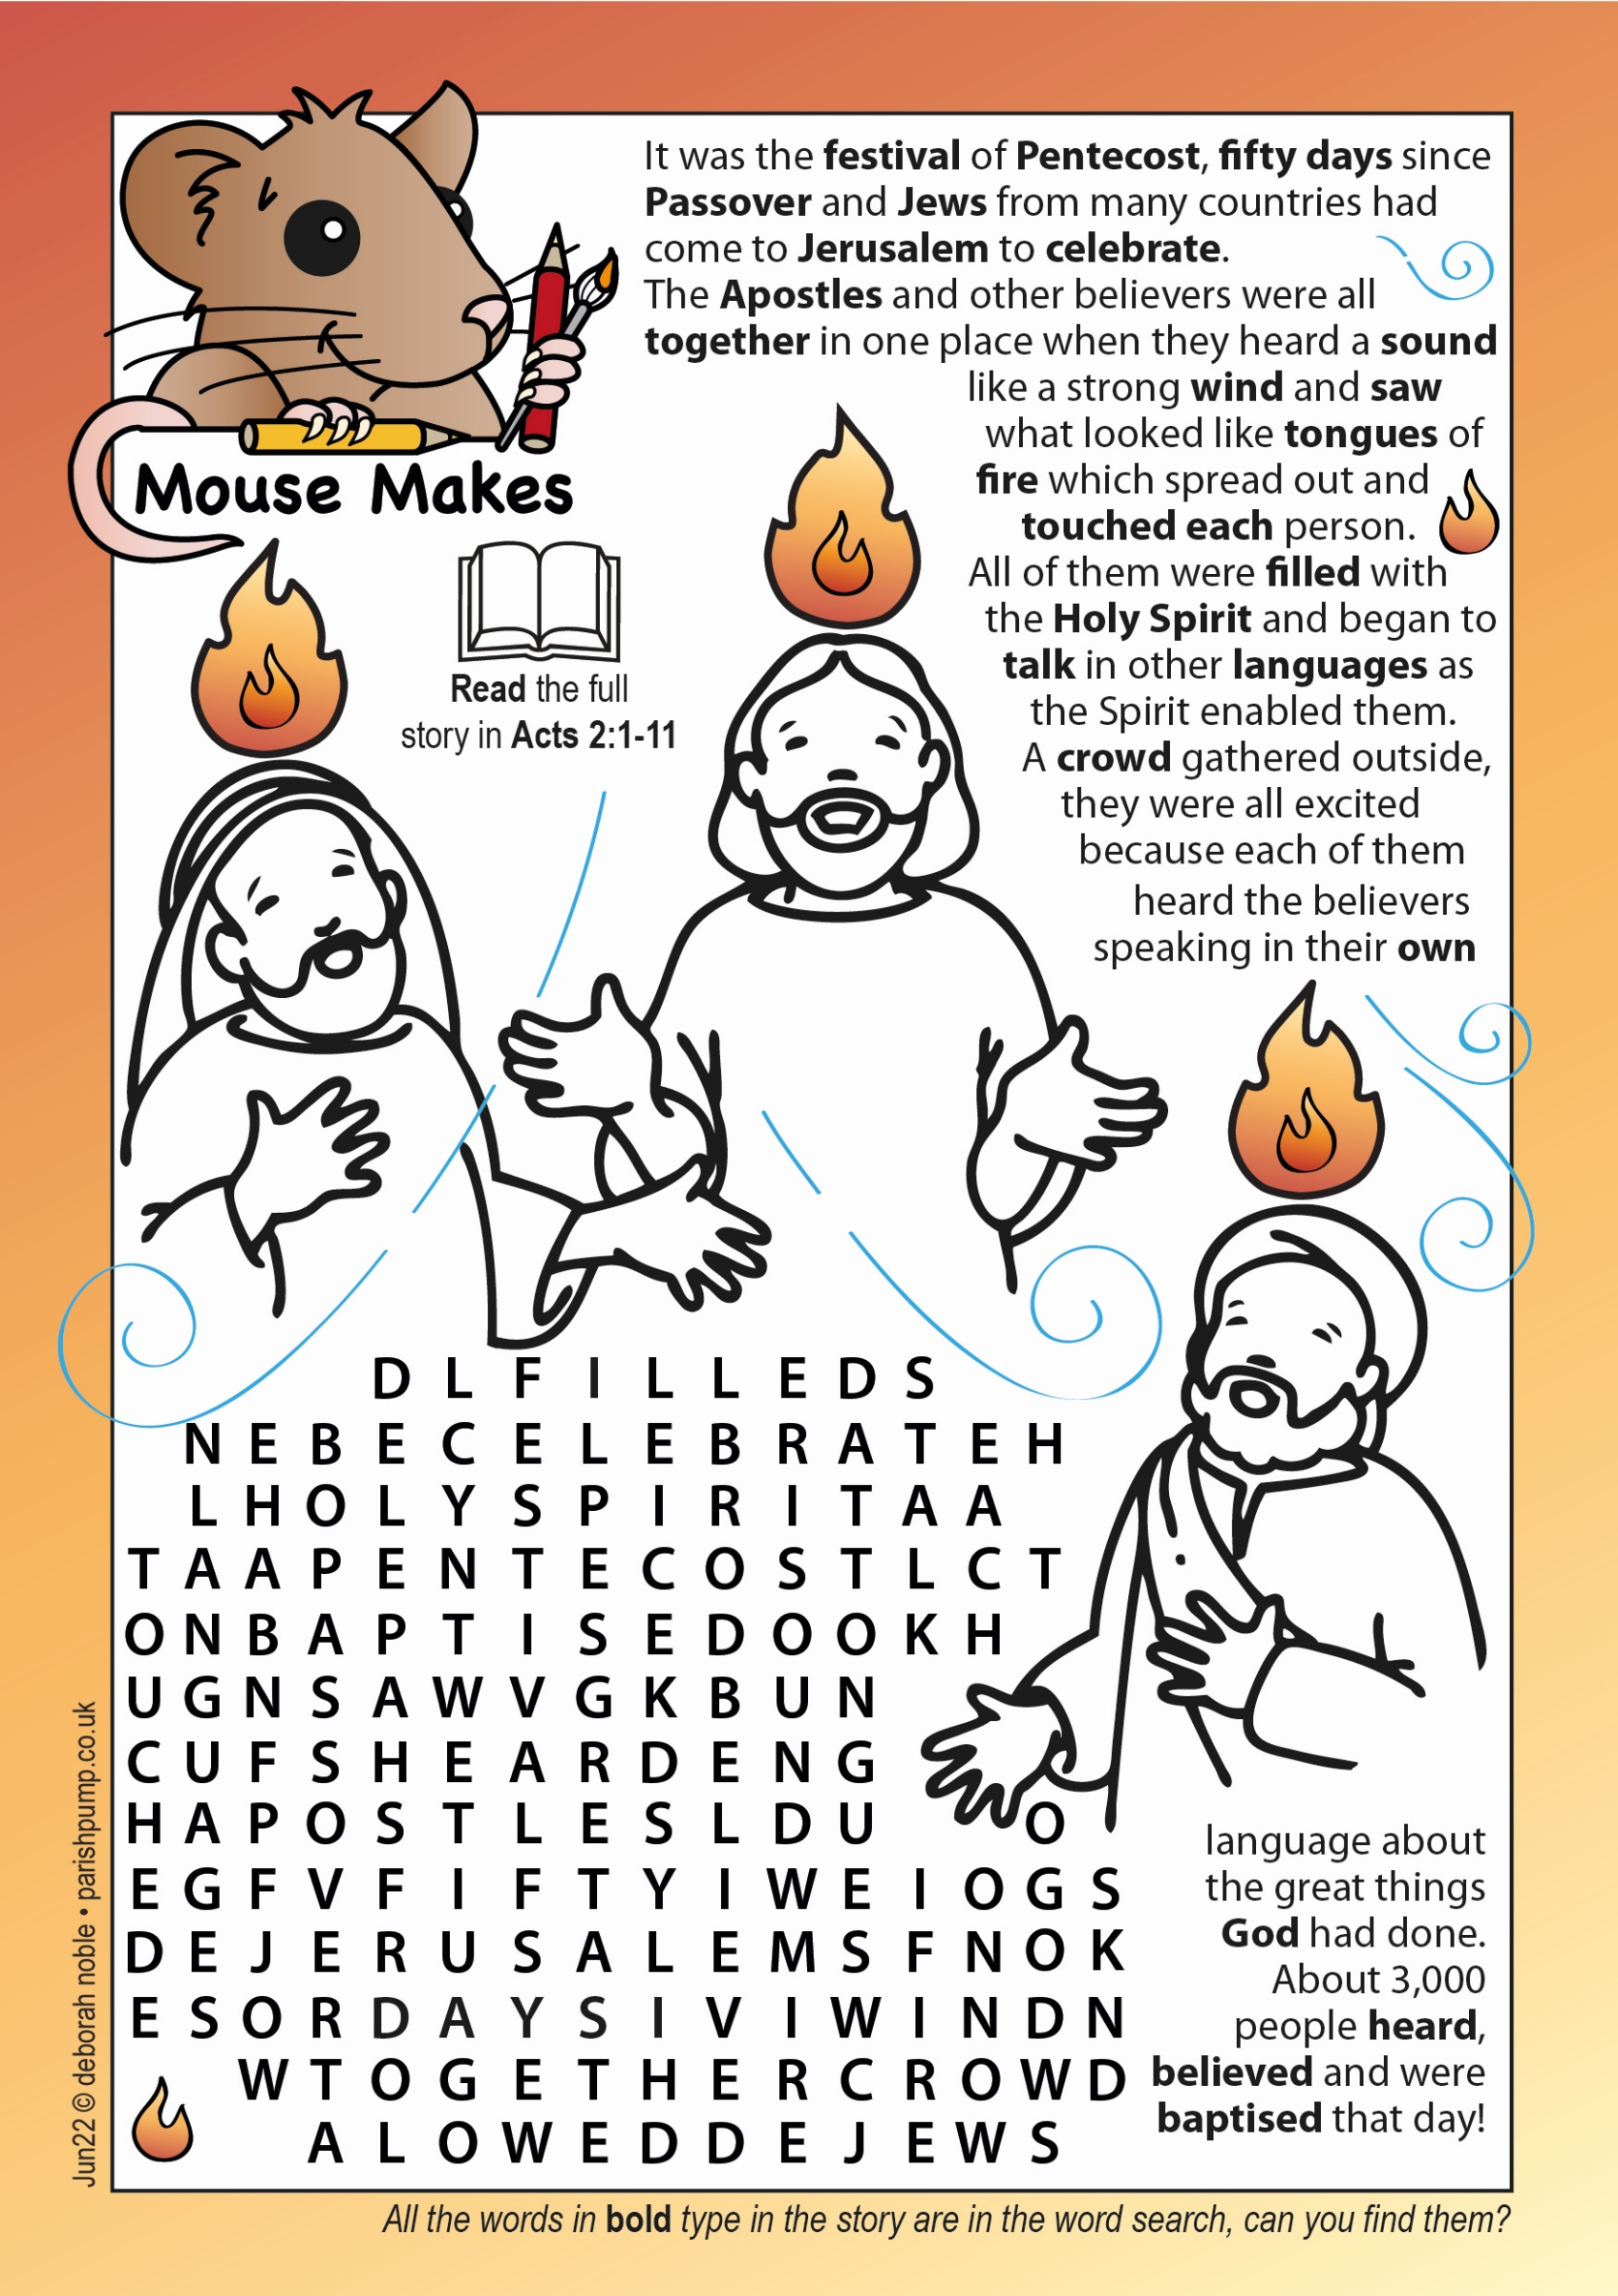

Editor’s Humour
Online readers - don’t forget to click on the pictures and links to learn more!
An 80-year-old lady was marrying for the 4th time.
A newspaper asked if she wouldn't mind talking about her ﬁrst 3 husbands and what they did for a living.
She smiled and said, "My ﬁrst husband was a banker, then I married a circus ringmaster, next was a preacher and now in my 80's, a funeral director.
When asked why the 4 men had such diverse careers.
She explained, "l married one for the money, 2 for the show, 3 to get ready and 4 to go."
__________ __________

"One for the Money" is an English-language children's rhyme. Children have used it as early as the 1820s to count before starting a race or other activity.
The full rhyme reads as: - One for the money, Two for the show; Three to make ready, And four to go. The rhyme was used by Carl Perkins as the lead in to the rockabilly song “Blue Suede Shoes” made popular by Elvis Presley in 1956
Prayer for the Month

Holy Spirit, sent by the Father,
ignite in us your holy fire;
strengthen your children with the gift of faith,
revive your Church with the breath of love,
and renew the face of the earth,
through Jesus Christ our Lord. Amen.

On the first Sunday in June we celebrate Pentecost. It marks the end of the Easter season and is often called the Church’s Birthday. This year we will be celebrating Pentecost in the evening as we will be celebrating the Queen’s Platinum Jubilee on the morning of the 5th of June.

This month’s prayer is the alternative collect for Pentecost, the feast of the Holy Spirit. For me this prayer articulates the work of the Holy Spirit in the Church, in the believer and in the world.

We pray for the revival of the Church - a much needed prayer in the West as the Church declines in size and influence. This prayer reminds us that the Church will not be rescued by our efforts or by better management, but only by the Holy Spirit at work in and through the Church. The Spirit enables the Church to worship and to fulfil our calling to witness to the love of God in Christ.

Without the Spirit the Church is no more than an institution; with the Spirit the Church is the body of Christ. So this Pentecost we pray for the Holy Spirit to renew Christ’s Church in worship and in love.

The Holy Spirit enables Christians to experience the presence of Christ. Without the Spirit, faith can be a dry intellectual exercise; the Spirit enables us to know Christ and the Father for ourselves (rather than simply knowing about the Father and the Son).

We pray for the renewal of God’s creation. We see human greed and carelessness devastating the earth. We see human lives broken by violence and war; the innocent suffer, and the wicked seem to prosper. We pray for the Holy Spirit to renew the world, to change the world by transforming men and women, changing hearts and minds.

The symbol of the Holy Spirit is fire. A reminder of the power and the uncontrollable nature of God’s Spirit. It is a reminder that we are not in charge, and a reminder that we are called to work, not in our own strength, but in God’s.

May God the Holy Spirit fill us, fill the Church and fill God’s world bringing renewal, healing and peace. Amen.

Apple’s first iPhone

Just 15 years ago, on 29th June 2007, Apple released the first iPhone.

From the original concept of an efficient, easy-to-use, slick mobile phone, it transformed by the time of its creation into what was described by Brian Merchant, author of The One Device, as the “primary platform for thousands of apps offering streaming music and video, real-time video chat, addictive videogames and virtual and augmented reality experiences”.

Steve Jobs, founder of Apple, called the iPhone a “revolutionary and magical product” that “fits beautifully into the palm of your hand”. Five years after its debut, more than 200 million had been sold. Merchant calls it a “culturally dominant, world-eating phenomenon”.

From the outset, the iPhone was hugely popular, with queues forming for hours outside Apple stores in both Europe and America on its release. In addition, Jobs provided an iPhone free to all his employees.

To some Christians, the Apple logo is disturbing, suggesting that eating the fruit in Eden opened the door to enlightenment – Jobs was a devotee of Eastern mysticism. While Christianity offers faith and hope, they suggest that Apple offers a convenient life, enabled through technology.

Other Christians, however, point out that Apple technology has enabled the Gospel to be widely heard and, in many senses, seen. FaceTime through the iPhone also made a dramatic and positive difference to people’s lives under lockdown.

Lyncham Cocker Spaniels
Yorkshire Terriers & Toy Poodles

Puppies sometimes available
We also have Cockerpoos & Yorkipoos

Chapeltown – Sheffield – South Yorkshire

Phone: 0114 245 5322 - Mobile: 0795 268 8420

Website: www.lyncham9.co.uk - Email: lyncham9@hotmail.com

Fully Licensed
Help needed in the church garden

If you can, mow, weed, strim, sweep, pickup sticks, rake leaves or drive a sit on mower, we need you. If you can spare just one or two hours a week it would be a great help. Not only will the church look good, but you might even feel your spiritual and physical well-being improve and in our small way help the environment. We come to the churchyard every Tuesday and Friday afternoon (weather permitting) followed by a drinks and biscuits, sometimes even a cake.

Any help most welcome. Thank you. Pat Wood

Whitley Hall Cricket Club

The cricket season is now well underway although the promised hot weather has not yet really arrived. The 1st XI has made a good start with a sucessful first game at home against Sheffield Collegiate where the target of 170 was too much for the visitors who were bowled out for 127 – just deserts after losing the equivalent match last season by 1 run on the final ball! Since then, there have been victories over Barnsley and Elsecar away and a win at home over Cleethorpes but defeats at the hands of Tickhill away and Appleby Frodingham at home.

28th May saw Treeton visit Baxter Field and Whitley batted firs achieving 259 with a captain’s innigs of 69 from James Moorhouse. Treeton were 77 for 6 quite early on but a century for their opening batsman Viraj Bhosale brought the score to 200 for 7 with Whitley regaining control late on to win by 35 runs. In the league, the 1st XI are currently 4th with 5 wins out of 7 games. Whitley met Barnsley in the Viking Yorkshire Knock-out cup on 2nd May and this time Barnsley were victorious.

The first T20 Blast competition was held at Baxter Field on 21st May where Cawthorne and Whiston made up the three teams. Whitley had a good day with many spectators and the team sits in 3rd place in the overall competition.The 2nd XI has had a reasonable start with 4 wins from 7 games and are above mid table and the 3rd XI has had a challenging start with 3 wins out of 6 games.

Anyone interested in joining us, please contact the Secretary in the first instance (details below).

Spectators are welcome to use all the facilities in the pavilion where drinks and snacks are available.

Fixtures at Baxter Field, Cinder Hill Lane (12 noon start)

4th June | 2nd XI | v | Sheffield United 1st XI
11th June | 1st XI | v | Whiston 1st XI
18th June | 2nd XI | v | Wakefield 2nd XI
25th June | 1st XI | v | Doncaster 1st XI
2nd July | 2nd XI | v | Upper Haugh 1st XI

Contact: Joe Webster, Secretary: 07969 014592
whitleyhall@ycspl.co.uk
Andrew Robinson

The Gardening Year – June

Container Grown Vegetables

Leeks, traditionally take up a lot of space for a long time in the vegetable plot. However, they can be grown in large pots and raised to be harvested when small. They are worth growing because they are available during winter when many other crops are over. You need a large container at least one foot deep and one foot across, fill with compost and water it to firm it up. now if your leeks have long roots trim them to about 2 inches. Dibble a hole the length of the leek about 1 inch in diameter and drop the leeks in 2 inches apart. Just leave 1 inch of leek above the hole. Gently put a little water down the hole. Once they are growing well, leeks take pretty much care of themselves, as long as you keep weeds away and water during dry spells.

Onions, it is not worth growing large onions in pots or containers but spring onions work well and are ideal for adding to salads or stir fries. Spring onions need free draining but moisture retentive soil that does not become waterlogged. This is much easier to manage in containers than in the ground. Keep spring onion seedlings moist until established. There is no need to thin them, just pull the onions when young and thin. White Lisbon is the most popular spring onion, which is quick cropping and very hardy.

Kale, there is really only one member of the cabbage family that I would grow in containers, and that is Kale. Kale is a great contender for pots and makes a useful vegetable for harvesting throughout the winter. it is simple to grow and ideal for beginners. It will grow in part shade and improves its taste during cold weather. Kale is not a particularly fussy plant as long as it is given enough water and not choked by weeds. Dwarf Green Curled is a popular choice for containers.

Colin Williams

Eat the Seasons – June

Vegetables - Artichoke, Asparagus, Aubergine, Beetroot, Broad Beans, Broccoli, Carrots, Chillies, Courgettes, Fennel, French Beans, Garlic, Jersey Royal New Potatoes, Kohlrabi, Lettuce & Salad Leaves, Mangetout, New Potatoes, Onions, Pak Choi, Peas, Radishes, Rocket, Runner Beans, Samphire, Spinach, Spring Onions, Tomatoes, Turnips, Watercress, Wild Nettles
Fruit - Apricots, Bilberries, Blueberries, Cherries, Gooseberries, Greengages, Kiwi Fruit, Peaches, Strawberries
Herbs - Basil, Chervil, Chives, Coriander, Dill, Elderflowers, Oregano, Mint, Nasturtium, Parsley (Curly), Parsley (Flat-Leafed), Rosemary, Sage, Sorrel, Tarragon, Thyme
Meat - Lamb, Wood Pigeon
Fish – Cod, Coley, Crab, Haddock, Halibut, Herring, Langoustine, Plaice, Pollack, Prawns, Salmon, Sardines, Scallops (Queen), Sea Bream, Sea Trout, Shrimp, Squid, Whelks, Whitebait
Visit - www.eattheseasons.co.uk

‘Little Silver’
Editor: The Revd Richard Higginbottom looks at the meaning of ‘platinum’

If you have ever had chemotherapy, or a heart pacemaker installed, you will be particularly grateful for the properties of platinum.

Platinum compounds disrupt the multiplication of cancerous cells, and the properties of platinum itself (its resistance to corrosion and tarnishing) make it particularly suitable for electrical contacts in pacemakers. But platinum has other properties which make it a topical subject.

The word ‘Platinum’ comes from the Spanish for ‘little silver’ (‘plata’ meaning silver, as in the River Plate in Argentina.) Platinum is very rare. It is much rarer than gold. It is therefore very precious and has generally been more expensive than gold.

Platinum is used to make the International Standard Weights and Measures. The International Standard Kilogram is made from platinum alloys which can be relied upon not to vary over time. Platinum is a very dense metal. It is denser than pure gold. It carries a great deal of ‘gravitas.’

Platinum is what scientists call a ‘Noble Metal’ – because it can withstand almost any chemical attack. It is the least reactive of all metals.

All these characteristics apply well to our much-loved Queen. She is ‘petite and silver’, she has ‘gravitas’, and she has remained untarnished over a very long period of time, despite having been in constant contact with all manner of people.

The Queen is a very rare person indeed, and very precious to our nation, setting the highest reliable standards of public service and carrying with her immense gravitas and unquestionable nobility.

The Queen’s Imperial State Crown is made of gold, silver and, appropriately enough, platinum, and decorated with many precious stones. As the first British monarch to celebrate a Platinum Jubilee, she wears it well.

We thank God for her, and for her qualities that have made her so special. God Save our Noble Queen!
___________________________________________________________________

Crossword Puzzle - Solution is here
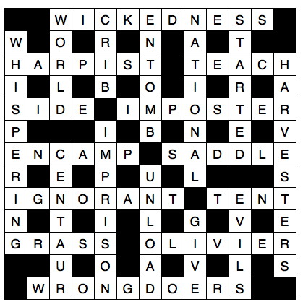
ERIC EYRE
Funeral Services
… over 60 years of personal service

- A fully qualified privately owned & Independent Family Funeral Service.
- Offering a caring & dignified service, private rest rooms, coffin selection, floral tributes & memorials.
- Catering available on request in our own reception rooms or the venue of your choice.
- Pre - Payment Funeral Plans Available.

The Funeral Home  Mortomley House  2 & 4 Mortomley Lane  High Green  0114 284 8202 | 826 Barnsley Road  Sheffield Lane Top  0114 327 1720  34 Housley Park  Chapeltown

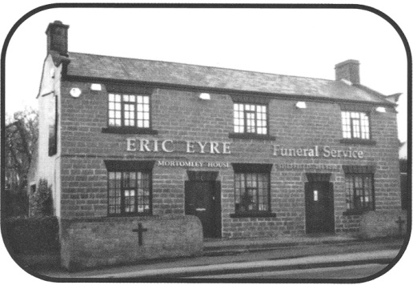
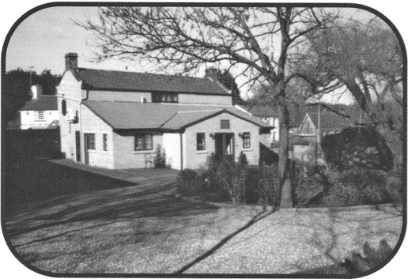

It is time to eat Strawberries

Synonymous with summer, the British strawberry season begins with the arrival of early season fruit grown under cover. Imported strawberries, now sold for most of the year, are picked whilst slightly under-ripe to ensure that they don't turn into mush during transportation. However strawberries do not ripen after being picked and so imported strawberries are often hard and have an undeveloped flavour - a pale imitation of in-season British strawberries.

The flavour of strawberries can be really brought out with the addition of a simple dressing. Gently heat some balsamic vinegar and/or orange liqueur, add an equal volume of sugar and stir to dissolve. Allow to cool and pour a little (less is more) over the strawberries. Stir gently and leave at room temperature to macerate for half an hour. Serve, of course, with plenty of cream.

Strawberries are native to both Old and New worlds. They have been eaten since Roman times, when they were also used medicinally to help with digestive ailments, discoloured teeth and skin irritations. The strawberries available today are derived from varieties that were originally developed in the seventeenth century.

The strawberry plant, genus Fragaria, is a member of the rose family. Strawberries are not technically fruit, but pseudocarps (also known as false fruit or accessory fruit). A pseudocarp is a fruitlike structure consisting of tissue that is not derived from the ovary wall. The true fruits of the strawberry plant are actually the small seeds (achenes) found on the outer surface.

When buying look for berries that are unblemished and bright red with fresh-looking green leafy caps. The fruit should be not too firm and not too soft (there should be no dampness on the bottom of the container). The scent is an indicator of quality and smaller strawberries often have more flavour. Strawberries absorb water readily and so are best served unwashed: choose organic fruit to reduce the levels of toxins you may be ingesting. Try seeking out a Pick-Your-Own farm or local farmers' market to get the freshest. If you've bought organic strawberries you can just wipe them with a damp kitchen towel. Non-organic strawberries should be rinsed and wiped clean. Gently pat dry before removing the caps and white hull with a paring knife. Serve at room temperature.

Strawberries are highly perishable; some may keep for 2 or 3 days but others will be past their best within 24 hours. If not eating on the day of purchase, spread on a shallow plate, cover with paper towels and store in a sealed container or plastic bag in a cool place. They can be frozen: spread unwashed strawberries in a single layer, freeze until solid and then transfer to a freezer bag. Strawberries are rich in vitamin C, Manganese and Folic Acid. They are a good source of ellagic acid (a phytochemical thought to combat carcinogens) and contain antioxidant flavonoids (linked with protecting against heart disease, stroke and cancers).

When making jam look for strawberries that are on offer (close to their sell by date) and buy 1.2kg of berries for every 1kg of jam sugar (sugar with pectin) cooking instructions are usually on the sugar bag – makes 3 to 4 jars of home-made jam with 55% fruit yum…

The ancient Roman practice of using strawberries as a natural teeth whitener is still being championed today. Josephine Fairley, author of The Ultimate Natural Beauty Book, recommends crushing a ripe strawberry with a little baking powder, brushing onto the teeth and leaving for five minutes before brushing again and rinsing.
Do you, your family, friends or neighbours shop at Amazon.co.uk?
If you do, you can support St Mary’s Church at no extra cost.
Just shop at smile.amazon.co.uk – where you will find the exact same prices, selection and shopping experience, but with the added bonus that AmazonSmile will donate 0.5% of your net purchase price of eligible purchases to St Mary’s Church.
Spread the word, and happy shopping!

Remember to select “Ecclesfield Church” as your charitable organisation before you shop, or use this link which does it for you
https://smile.amazon.co.uk/ch/1144309-0

Chapeltown & District Probus Club

Ian Webb was the guest speaker in May and gave a fascinating illustrated talk of his own climb up Mount Denali (Mount McKinley). At 20,310 feet, Denali is the highest peak in Alaska and the third most prominent and third most isolated peak on Earth (Everest is No. 1). Ian went through some of the physical routines and risks which achieving this height involved. After the meeting, 21 members enjoyed an excellent lunch at Wortley Hall.

The club offers friendship and companionship to members with a focus on men who are semi or fully retired. We have an interesting and varied list of speakers followed by lunch at Wortley Hall. The club also has seasonal lunches and visits to which members’ family and friends are invited. New members are always welcome and if you might be interested, why not come as a guest to see what it is like and join us for lunch? If you are from Grenoside, we are in your village.
If you are interested or would like to join a meeting as a guest, please make contact with the Secretary, Trevor Winslow (see below).

Upcoming meetings at 10.00 in Grenoside Community Centre
(followed by lunch at Wortley Hall):

8th June – Jeff Jacklin “Retirement”
13th July – Ian Morgan “Bolsover Through the Ages”
10th August – Paul Adey “History of the British Motor Industry part 2”

Contact details: E-Mail chapeltown.probus@gmail.com
Website https://chapeltown-probus.org.uk/
Andrew Robinson
Crossword Puzzle

Clues Across

1 Evil (Genesis 6:5) (10)
7 Musician called for by Elisha when he met the kings of Israel, Judah and Edom (2 Kings 3:15) (7)
8 The request that led to the institution of the Lord’s Prayer: ‘Lord, — us to pray’ (Luke 11:1) (5)
10 ‘We are hard pressed on every—’(2Corinthians4:8)(4)
11 Fraud (2Corinthians6:8)(8)
13 ‘His troops advance in force;they build a siege ramp against me and — around my tent’ (Job 19:12) (6)
15 Where Rachel hid Laban’s household gods when he searched his daughter’s tent (Genesis 31:34) (6)
17 ‘Now about spiritual gifts,brothers,I do not want you to be—’ (1 Corinthians 12:1) (8)
18 Nomadic dwelling(Genesis26:25)(4)
21 ‘As for man,his days are like—,he flourishes like a flower of the field’ (Psalm 103:15) (5)
22 Or I live (anag.)(7)
23 Those guilty of 1 Across(Romans13:4)(10)

Clues Down

1 ‘God so loved the — that he gave his one and only Son’ (John 3:16) (5)
2 ‘Away in a manger, no — for a bed’ (4)
3 Mob ten (anag.) (6)
4 ‘Each — group made its own gods in several towns where they settled’ (2 Kings 17:29) (8)
5 Began (Luke 9:46) (7)
6 Speaking very softly (John 7:32) (10)
9 Workers Ruth joined when she arrived in Bethlehem with her mother-in-law Naomi (Ruth 2:3) (10) 12 Put in jail(Acts22:19)(8)
14 Aceturn(anag.)(7)
16 Discharge(Acts21:3)(6)
19 ‘All these—come from inside and make a man “unclean”’ (Mark 7:23) (5)
20 ‘Let us rejoice and be glad and — him glory!’(Revelation19:7)(4)

Solution is on Page 23
Prayers and Poems Page
Prayer for June - By Daphne Kitching

Heavenly Father,
Thank you for the beauty of the world you created, so evident in this lovely month of June.
We bring before you, in prayer, those events going on in the world which are so difficult to understand. We pray for all your children who are suffering in any way, especially those affected by war. Please, Lord, comfort them, assure them of your presence - and deliver them from evil.
May we appreciate each day which you have made. Help us to rejoice and be glad in the gift of each new day - and to trust you for all our tomorrows, knowing that in you alone is our security.
In Jesus’ name. Amen

Spirit of God By Daphne Kitching  (Gen 1:2,2 Tim 3:16, Mk 1:8, Acts 2)  Dancing with the Father  And the Son  In beginning the beginning,  You were there  Spirit of God,  Breath of life,  Creator.  Revealing words and wisdom  To prophets and apostles,  To scribes and editors,  You were there  In discernment,  Spirit of God,  Inspirer.  Filling with life and power,  With truth and courage,  Overwhelming with love and praise,  You were there  At Pentecost,  Spirit of God,  Enabler.  Longing to come,  To dance, to reveal,  To fill, to overwhelm,  To create and inspire and enable,  Spirit of God,  You are here  In fullness.  Baptise us. |  | A (Royal) Dog’s Life - By Nigel Beeton  We dogs, who live with royal folk  Who feel Her Maj’s royal stroke;  We like to hear important talk  Of dinner time, and our next walk.  But lately there’s been so much rushing  People bowing, people fussing.  Trumpets blare and soldiers shout  What is all the noise about?  No-one thinks of corgis’ needs  Like, where’s our bone, and where’s our leads?  We’re not allowed a doggy romp  ‘Midst all the pageantry and pomp!  Adding to our canine woes  They all wear their finest clothes,  So we’re all stuck behind closed doors  Lest we might smudge them with our paws.  But things will come to settle down.  It’s life, when Mistress wears a crown;  Yes, it will pass, you all will see  This business of the Jubilee.  So, we shall wag our doggy tails!  Be happy, like the Prince of Wales!  We think the Boss has done just fine  Being Queen for all this time!
A Small Drop of Water  A small drop of water slowly  To thy forehead, belov’d one,  Meet for Father, Spirit, Son,  Trinity of virtue holy. | A small drop of water slowly  To encompass, belov’d one,  Meet for Father, Spirit, Son,  Trinity of virtue holy. |  | A small drop of water slowly  For each grace’s filling done,  Meet for Father, Spirit, Son,  Trinity of virtue holy.  Ancient Celtic baptism blessing
 | Contact Numbers for Local Groups
 | Ecclesfield Rainbows  Gatty Hall  Tuesday 5.00 pm to 6.15 pm  Leader - Debbie  Tel: 0786 047 1793  Ecclesfield Brownies  Gatty Hall  Monday 5.30 pm to 6.45 pm  Leader - Mrs J Hutchinson  Tel: 0798 344 2742  Ecclesfield Brownies  Gatty Hall  Tuesday 6.15 pm to 7.45 pm  Leader - Mrs A. Kendall  Tel: 0114 246 8866  Ecclesfield Guides  Gatty Hall  Thursday 6.30 pm to 8.30 pm  Leader - Mrs C Topham  Tel: 0114 246 1289  Ecclesfield Priory Players  EPPIC Theatre  Monday 7.30 pm to 10.00 pm  Wednesday 7.30 pm to 10.00 pm  Secretary - Emma Addy  Theatre Tel No. 0114 240 2624  Ecclesfield Community Garden  Ecclesfield Park - Located between Ladycroft bridge/stream and Bowling greens. Open Wednesday + Saturday  10 am to 12 noon  Tel: Robert 0114 246 1095  Friends of Ecclesfield Library  Run by the community for the community.  Volunteer helpers always needed.  Tel: 0114 246 3651  email: ecclesfieldlib@gmail.com |  |  | Ecclesfield Cubs  Scout Hut (off Yew Lane)  Wednesday 4:45 pm to 6:15 pm  2nd Pack 6.30 pm to 8.0 pm  Leader - Mrs A Hancock  Tel: 0114 245 2780  Ecclesfield Beavers  Scout Hut (off Yew Lane)  Monday 6.00 pm to 7.15 pm  Leader - Mrs J Steel  0114 246 0218  Thursday - 5.45 - 7.00 pm  Shane Porteous  shane@ecclesfieldscouts.org.uk  Ecclesfield Scouts  Scout Hut (off Yew Lane)  Thursday 7:15 pm to 9:00 pm  Leader - Bryony Hemming  25thecclesfieldscouts@gmail.com  The Grenoside Singers  Practice Monday in St Mark’s  Church Hall at 7:30 pm  Secretary: Judith Gill Tel: 0782 411 2584  www.grenosidesingers.co.uk  Whitley Hall Cricket Club  Matches every Saturday and some Sundays and weekdays.  Please make contact if you wish to play or learn. Secretary: Joe Webster: whitleyhall@ycspl.co.uk  Website:  www.whitleyhall.play-cricket.com  Chapeltown and District PROBUS Club  Meets every 2nd Wednesday in the month  in Grenoside Community Centre  All retired and semi-retired gentlemen welcome  Contact the Secretary: Trevor Winslow chapeltown.probus@gmail.com  We are now on face to face see  www.chapeltown-probus.org.uk
If you would like your local group advertised, please contact:
Mrs P Blackburn 0114 246 8453
Useful Contacts
 |  | Vicar | Revd Tim Gill |  |  | 257 0002
 |  | E-mail: ttim.gill@sheffield.anglican.org
 |  | Churchwardens: | Ann Hackett |  |  | 246 7159
 |  |  | Jo Hawksworth |  |  | 246 2852
 |  |  | Michael Waldron |  |  | 246 3091
 |  |  | Vacancy
 |  | Readers:
 |  | Pastoral Workers:
 |  | Church Office:
 |  | Tuesday 9:00 am to 1.00 pm
 |  | Thursday 9.00 am to 12.00 pm |  |  |  | 245 0106
 |  | Church Choir Practice in Church
 |  | 3.00pm on the first Friday of each month
 |  | Music Group Practice in Church
 |  | Thursday 7:30 pm - Contact: Andrea Whittaker |  |  |  | 246 0746
 |  | Mother’s Union in Gatty Hall
 |  | 1st Wednesday of month 1:00 pm
 |  | Contact: Stephanie Hartshorne |  |  |  | 245 9435
 |  | Ecclesfield Ladies Group in Gatty Hall
 |  | Thursday 7.30 pm - Contact: Anne Rostron |  |  |  | 245 5492
 |  | Bell Ringers meet in Church Belfry
 |  | Tuesday 7:30 pm Contact: Phil Hirst |  |  |  | 286 2766
 |  | Gatty Hall Bookings,
 |  | Contact us on: |  |  | 0780 307 8223
 |  | Baptisms: Contact: Revd Tim Gill |  |  |  | 257 0002
 |  | Weddings: Contact: Revd Tim Gill |  |  |  | 257 0002
 |  | “ Or email: ttim.gill@sheffield.anglican.org
 |  | Office e-mail office.stmarys.ecclesfield@googlemail.com
 |  | Magazine e-mail stmarys.magazine.ecclesfield@gmail.com

